

***VACATION RENTAL SYSTEM***

***TA: Dr \Sara Nagy***



**Information System Project Members Names**:

***A****hmed Khaled mowed ...* ***sec****tion* ***1***

***A****bdurrahman Mohamed …****sec****tion* ***9***

***A****bdallah Mahmoud Mohammed ElGhayad …****sec****tion* ***9***

***A****bdurrahman Ashraf ...* ***Sec****tion* ***9***

***I****slam Ashraf …****Sec****tion 4*

***S****ameh Sayed hammad …****sec****tion****7***

December 5, 2018

fcis

Ain Shams

# ***1-UpdatePlaces: -***

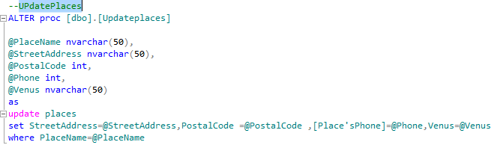

***2-UpdateUsers: -***

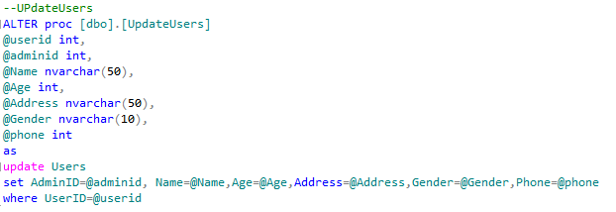

***3-SearchPlaces: -***

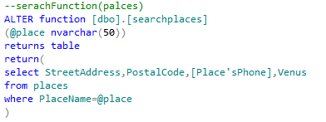

***4-DeleteCheckers: -***

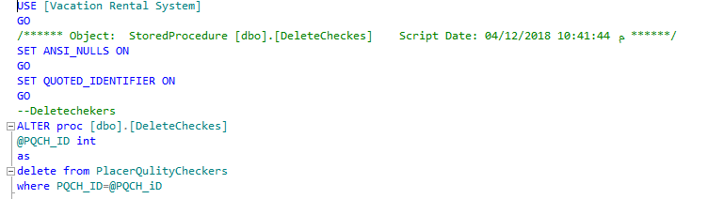

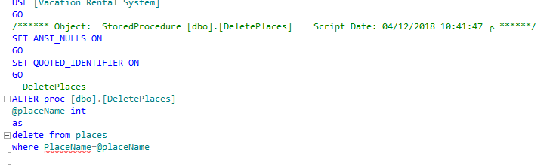***5-DeletePlaces: -***

***6-DisplayPlaces: -***

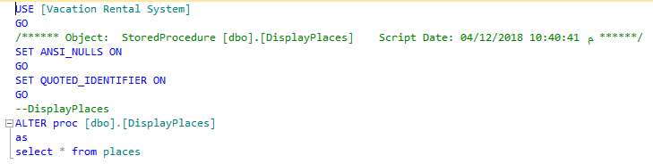

***7-DisplayUsers: -***

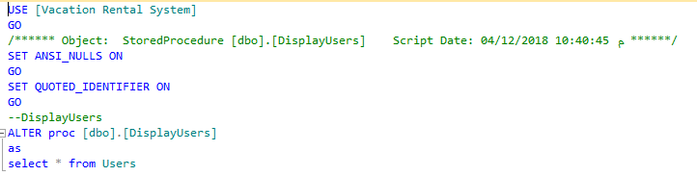

***8-InsertAdmin: -***

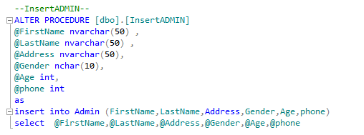

***9-InsertCheckers: -***

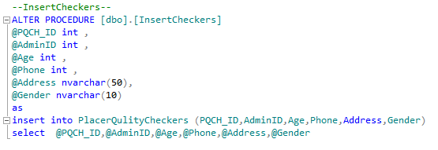

***10-InsertUsers: -***

